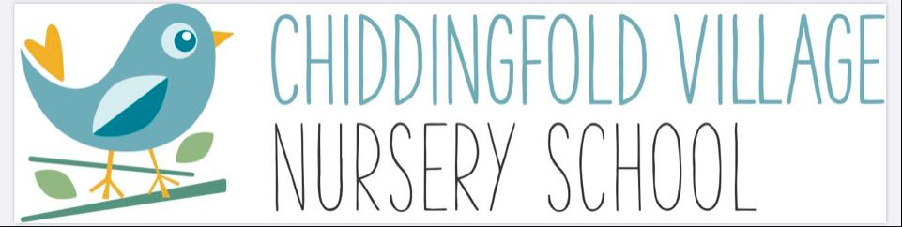

Covid-19 Health & Safety Policy for Chiddingfold Village Nursery School

Early Years Educational Effectiveness
June 2020

POLICY AIM: To ensure that the risks of Covid-19 presented to children, staff and visitors are reduced to an acceptable level.

POLICY OBJECTIVES: To conduct all our activities safely and in accordance with legislative standards and in consideration of government guidance

To provide safe working and learning conditions

To ensure a systematic approach to the identification of risks and the allocation of resources to control them

To openly communicate on health safety and welfare

POLICY STATEMENT: Chiddingfold Village Nursery School recognises and accepts its responsibility as an employer and provider of services and will provide a safe and healthy workplace and learning environment for all staff, children and such other persons as may be affected by its activities.

We will adopt health and safety arrangements under Covid in line with Health & Safety legislation, and in consideration of government guidelines.

Good health and safety management will be an integral part of the way that the setting operates and will be considered across all work activities and across the wide range of educational activities delivered.

SIGNED:

……………………………………… Owner/Manager ………………. Date

.……………………………………. Chair of Committee …………………. Date

THE SETTING WILL:

- Apply and communicate sensible risk management and safe working practices. This will involve:

  - Regular assessment of hazards and associated risks

  - Implementing preventive and protective control measures against those risks to an acceptable/ tolerable level

  - Monitoring the effectiveness of those measures by senior leaders

  - Provision of information, instruction, training and protective equipment to staff (and children where required)

  - Review of risk assessments, policies, procedures and practices at regular interval and where additional information is gained through changes in government guidance, monitoring or following an incident.

- Implement measures to ensure social distancing is observed across the site and in all buildings consistent with and appropriate to the numbers of children, staff and visitors in the setting

- Maintain an appropriate hygiene regime to be followed by all children, staff and visitors

- Operate an enhanced cleaning regime for the duration of Covid

- Ensure that staff are informed and instructed to ensure competence and awareness of health & safety precautions required during Covid

- Educate children about Covid-19 and to encourage and re-assure them about the measures in place to protect themselves from it.

- Require all employees and encourage and support all children to show a proper personal concern for their own safety, for that of the people around them.

- Require staff to exercise increased due care and attention and observe safe working methods.

- Communicate regularly and effectively with staff and parents about the setting’s response to Covid-19

- Put in place the support required for the return of children with special educational needs and disabilities (SEND) in line with education health care (EHC) plans in conjunction with families and other agencies

- Put in place any flexible working arrangements needed to support delivery of education and childcare during Covid-19 including where necessary staggered start/end times

- Put in place measures to check on staff wellbeing (including for leaders).

- Draw up contingency plans for:
  - Someone falling ill or demonstrating symptoms on site
  - Deep cleaning in the event of an outbreak of Covid-19 on site

- Provide appropriate personal protective equipment (PPE) as required by staff.

This policy has been reproduced with the kind permission of Bracknell Forest Council.

