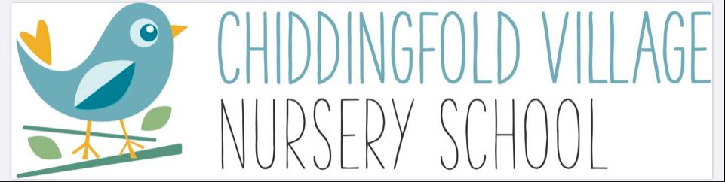

Cleaning and Sanitising Guidance for Chiddingfold Village Nursery
Early Years Educational Effectiveness
June 2020

COVID-19 Cleaning in non-healthcare settings

COVID-19 is mainly passed on by person-to-person, spread between people who are in close contact with one another and by droplets produced when an infected person coughs or sneezes.

It can also spread through contact with a surface or object that has the virus on it. Cleaning helps minimise the spread of coronavirus (COVID-19).

The risk of infection depends on many factors, including:

- the type of surfaces contaminated
- the amount of virus shed from the individual
- the time the individual spent in the setting
- the time since the individual was last in the setting

The infection risk from coronavirus (COVID-19) following contamination of the environment decreases over time. It is not yet clear at what point there is no risk. However, studies of other viruses in the same family suggest that, in most circumstances, the risk is likely to be reduced significantly after 72 hours.
This guidance describes the cleaning required, the appropriate disposal of materials, the cleaning of equipment and hard surfaces, and the personal protective equipment (PPE) that should be worn.

What you need to know
- Clean and disinfect regularly touched objects and surfaces more often than usual, using standard cleaning products
- Cleaning an area with normal household disinfectant after someone with suspected coronavirus (COVID-19) has left, will reduce the risk of passing the infection on to other people
- Wear disposable or washing-up gloves and aprons for cleaning. When used, these should be double-bagged, stored securely for 72 hours and then thrown away in the regular rubbish after cleaning is finished
- Using a disposable cloth, first clean hard surfaces with warm soapy water. Then disinfect these surfaces with the cleaning products you normally use. Pay particular attention to frequently touched areas and surfaces, such as bathrooms, grab-rails in corridors and stairwells, and door handles
- If an area has been heavily contaminated, such as with visible bodily fluids, from a person with coronavirus (COVID-19), use protection for the eyes, mouth and nose, as well as wearing gloves and an apron
- Wash hands regularly with soap and water for 20 seconds, and after removing gloves, aprons and other protection used while cleaning

What to do if someone develops symptoms of coronavirus whilst at an education setting
If anyone develops coronavirus (COVID-19) symptoms in an education setting they must be sent home and advised to follow the staying at home guidance.
If an individual is awaiting collection, they should be moved, if possible, to a room where they can be isolated behind a closed door (depending on the age of the child) and with appropriate adult supervision if required. Ideally, a window should be opened for ventilation. If it is not possible to isolate the child, move them to an area which is at least 2 metres away from other people.
If the individual needs to go to the bathroom while waiting to be collected, they should use a separate bathroom if possible. The bathroom should be cleaned and disinfected using standard cleaning products before being used by anyone else.
PPE should be worn by staff caring for the individual while they await collection if a distance of 2 metres cannot be maintained (such as for a very young child or a child with complex needs).
If a member of staff has helped someone who was taken unwell with coronavirus (COVID-19) symptoms, they do not need to go home unless they develop symptoms themselves. They should wash their hands thoroughly for 20 seconds after any contact with someone who is unwell.

Principles of cleaning after the Individual has left the setting or area

Personal Protective Equipment (PPE) -please see PPE guidance document.

The minimum PPE to be worn for cleaning an area where a person with possible or confirmed coronavirus (COVID-19) is disposable gloves and an apron. Hands should be washed with soap and water for 20 seconds after all PPE has been removed.

If a risk assessment of the setting indicates that a higher level of virus may be present for example if there is visible contamination with body fluids, then the need for additional PPE to protect the cleaner’s eyes, mouth and nose may be necessary. The local Public Health England (PHE) Health Protection Team (HPT) can advise on this.

Cleaning and disinfecting

Public areas where a symptomatic individual has passed through and spent minimal time, such as corridors, but which are not visibly contaminated with body fluids, can be cleaned thoroughly as normal.

All surfaces that the symptomatic person has come into contact with must be cleaned and disinfected, including:

- objects which are visibly contaminated with body fluids
- all potentially contaminated high-contact areas such as bathrooms, door handles, telephones, grab-rails in corridors and stairwells

Use disposable cloths or paper roll and disposable mop heads, to clean all hard surfaces, floors, chairs, door handles and sanitary fittings, following one of the options below:

- Use either a combined detergent disinfectant solution at a dilution of 1,000 parts per million available chlorine

or

- a household detergent followed by disinfection (1000 ppm av.cl.) Follow manufacturer’s instructions for dilution, application and contact times for all detergents and disinfectants
or

- if an alternative disinfectant is used within the organisation, this should be checked to ensure that it is effective against enveloped viruses

Avoid creating splashes and spray when cleaning.

Any cloths and mop heads used must be disposed of and should be put into waste bags as outlined below.

When items cannot be cleaned using detergents or laundered, for example, upholstered furniture and mattresses, steam cleaning should be used.

Any items that are heavily contaminated with body fluids and cannot be cleaned by washing should be disposed of.

Laundry
Wash items in accordance with the manufacturer’s instructions. Use the warmest water setting and dry items completely. Dirty laundry that has been in contact with an unwell person can be washed with other people’s items.
Do not shake dirty laundry, this minimises the possibility of dispersing virus through the air.
Clean and disinfect anything used for transporting laundry with your usual products, in line with the cleaning guidance above.

Waste
Ensure that bins for tissues are emptied throughout the day.

Waste from possible cases and cleaning of areas where possible cases have been (including disposable cloths and tissues):

- Should be put in a plastic rubbish bag and tied.
- The plastic bag should then be placed in a second bin bag and tied.
- It should be put in a suitable and secure place and marked for storage until the individual’s test results are known.

Waste should be stored safely and kept away from children. You should not put your waste in communal waste areas until negative test results are known or the waste has been stored for at least 72 hours.

- If the individual tests negative, this can be put in with the normal waste
- If the individual tests positive, then store it for at least 72 hours and put in with the normal waste

If storage for at least 72 hours is not appropriate, arrange for collection as a Category B infectious waste either by your local waste collection authority if they currently collect your waste or otherwise by a specialist clinical waste contractor. They will supply you with orange clinical waste bags for you to place your bags into so the waste can be sent for appropriate treatment.

National guidance referred to in compiling this guidance:
https://www.gov.uk/government/publications/coronavirus-covid-19-implementing-protective-measures-in-education-and-childcare-settings/coronavirus-covid-19-implementing-protective-me

https://www.gov.uk/government/publications/covid-19-decontamination-in-non-healthcare-settings/covid-19-decontamination-in-non-healthcare-settings

https://www.gov.uk/government/publications/wuhan-novel-coronavirus-infection-prevention-and-control/covid-19-personal-protective-equipment-ppe

