Summer Term 2023 Newsletter

Dear Parents,
I hope you are all having a good Easter break. Although the weather is pretty grim!
The end of term show ‘Chicken Licken’ was a huge success. The children were amazing and we were so very proud of them. The coffee/tea/croissants and the Easter Egg Tombola beforehand raised £140 – thank you so much for your support, we will use this to buy lots of sand for our sandpit.
I thought I would update you on what has been happening at the nursery and future diary dates.

Staff News

- Unfortunately, Sam Pocock will not be returning to the nursery when her maternity leave ends. May I take this opportunity of wishing her all the best for the future.
- I am very happy to say that Mary Marshall, who has been covering Sam on her maternity, will now be a permanent member of the team.
- Congratulations to Sophie Low who is expecting her second child at the end of August.

Upcoming Fundraising Events

Sunday 21st May – Nursery Thrift Sale 10am-12noon
We will be asking for donations for the thrift sale a week before to be dropped off at the hall. On the day refreshments will be available.
Sunday 11th June – Chiddingfold Village Fete
The nursery will be having a stall at the fete. We will be doing ‘Name The Toy Puppy’ to win a big Pound Puppy. ‘Guess How Many Sweets in a Jar’ to obviously win the jar! Ceramic craft decorating. No donations are needed for our stall but we would really appreciate your support on the day. Fingers crossed the weather will be better than last year!
Date to be confirmed - End of term disco for the children
More details to follow.
We would like to give big thanks to Adele Wingrave and the fundraising committee for their continued support and commitment, we truly appreciate it.

Nursery Diary Dates
- May Bank Holiday – Monday ^{1st} May
Nursery will be closed on this day.
- Election Day – Thursday 4th May
Unfortunately the Village Hall is being taken over by the local election and so there will be no nursery. However, we are taking the opportunity and have organised staff training and a staff meeting on this day. I am sorry for any inconvenience caused by our closure but it really is out of our control. Obviously you will not be charged on the summer invoice for this date.
- Monday 8th May – Coronation of King Charles
Nursery will be closed on this day as it is a national holiday.
- Monday 29th May to Friday 2nd June
Half Term
- Nursery Leavers Alice Holt Trip – Tuesday 18th July
For the last few years we have taken the children who are leaving nursery for Reception Class to West Wittering for the day. Although the children enjoyed it last year we found that the beach is getting busier and so we have limited space and it is very weather reliant. Plus, a lot of the day is taken up with being in traffic in the coach. By the time we get to the beach we only have 2 hours before we have to leave again. Therefore, we have decided that this year we will take the children to Alice Holt for the day. We have booked the classroom there and will plan lots of forest adventures with more room to run around.
The nursery will be closed on this day.
Further details will be emailed to the parents of the ‘leavers’ in the next few weeks.
- Nursery End of Term Summer Show – Friday 21st July
The nursery children will be performing an end of term show on this day. The story is yet to be confirmed. Please note that this will not be a normal nursery day. The show will be followed by a ‘Leavers Presentation’ and a photo slide show of their last year at nursery. A very emotional day! More details will follow.

Autumn Term 2023
For those parents whose child will be returning in September 2023, if you would like to change/add days/sessions your child currently attends please could you email me as soon as possible. We have had lots of enquiries and new children starting and spaces are filling up quite quickly. At the moment we do have availability on all days but I would like to give our current children first choice of available sessions before they get filled. Thank you.

Summer Term Funding Declaration Forms
Forms will be handed out the first week of term for those children who are eligible for ‘Funded Early Education’. Please could you complete, sign and return to me as soon as possible. Thank you.

Invoices
I will be generating invoices during the first couple of weeks of term and will email them to individuals. However, please let me know if you would prefer to receive a paper copy. Please also remember that we no longer accept cash payments, I am sorry for any inconvenience this may cause. We have set up a card/contactless payment device at the nursery to make it easier. You can also pay using bank transfers via online banking. Methods of payments with details will be on the bottom of the invoice.
Now for the obligatory information………
Please remember to bring your child with a named coat and a named bag with a change of clothes, and a named bottle of water. Also, if possible, a pair of named wellington boots.
We do not allow any sugary drinks at our setting. If your child will be staying for lunch please put your child’s name clearly on the lunch bag/box as sometimes we may have more than one of the same design. As before please adhere to our healthy eating ……………

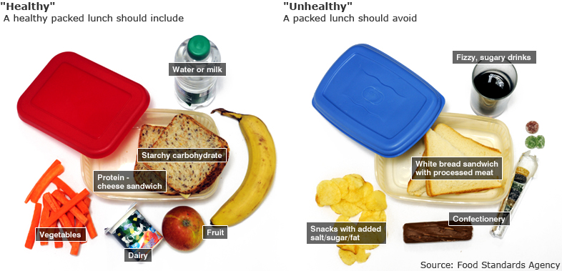

Allergies
We have children at nursery with a SESAME SEED allergy so please avoid any foods containing sesame in your child’s lunch. Therefore, we ask you to be extra vigilant with checking the ingredients of all food items in your child's lunch box/bag. Some of the items to be extra careful of are cereal bars and seeded breads. If you are in any doubt please do not use but find an alternative, such as wholemeal bread. Allergens are printed in bold on the ingredients information on the food packaging. Please note that Tahini (paste used in houmous) is made from ground sesame seeds so that is also something to look out for. As you also know we are a NUT FREE nursery so any food containing nuts is prohibited, this includes Pesto as it contains pine nuts.
Popcorn is also a prohibited item as it is deemed a choking hazard for early years children.

If you have any questions, please do not hesitate to contact me – administrator@chiddingfoldvillagenursery.co.uk

We are back on Monday 17th April.

Thank you.

Leigh and The Nursery Team

