Autumn 2021 Newsletter

Dear Parents,

I hope you have all had a really good summer.

We are looking forward to welcoming all the children when we return on Monday 6th September.

Although many restrictions have been lifted we will continue to use the side gate as our main entrance, where parents/carers can wait safely in the gated outside nursery play area, as we have found this has worked well over the last year. Please remember that on the notice board situated by the side gate there is a doorbell as well as up to date news and information for your interest.

Hopefully you have all received an email from me confirming sessions for your child. If you need to change any of these sessions then please let me know as soon as possible.

Staff
We said a sad farewell to Rory who left at the end of the summer term and we wish him lots of luck for his future endeavours. We will be welcoming Mollie Long who is joining the nursery team when we return next week. Mollie did voluntary work with us during the summer term, including going on the nursery leavers West Wittering beach trip, and proved to be very popular with the children.

Annual General Meeting - Wednesday 15th September 2021
The AGM will be taking place at The Half Crown Inn at 8pm. We are looking for parents to come on board and join the committee. Every parent as a member of our nursery has an automatic membership onto the parent committee and a say on how the nursery conducts its business. We need to elect some parent representatives therefore someone who can be the parents voice at committee meetings. We are also looking for fundraisers as we truly rely on money raised to purchase valuable resources for our nursery and the children.

Term Dates 2021/2022
I am attaching the term dates for 2021/2022 for your information.

COVID-19
Please be assured that we will continue to keep our setting safe and adhere to the policies that we have in place.

Autumn 2021 Funding Forms
When we return I will be handing out funding forms for those that are eligible for the 15 hours a week free funded childcare. I would very much appreciate it if these could be completed, signed and returned to me as soon as possible. Thank you.

Invoices
I will be generating invoices during the first week when we return. I have made a couple of changes in that we will go paper-less, therefore I will be emailing invoices to individuals. Please let me know if you would prefer to receive a paper copy. Another change is that we will no longer be accepting cash payments, I am sorry for any inconvenience this may cause. However, we have set up a card/contactless payment device at the nursery to make it easier. You can also pay using bank transfers via online banking.

Nursery Website
If you haven’t already please check out the nursery’s new website www.chiddingfoldnursery.co.uk. Hopefully you will find answers to any questions you may have.

Now for the obligatory information………
Please remember to bring your child with a named coat and a named bag with a change of clothes, and a named bottle of water. We do not allow any sugary drinks at our setting. If your child will be staying for lunch please put your child’s name clearly on the lunch bag/box as sometimes we may have more than one of the same design. As before please adhere to our healthy eating ……………

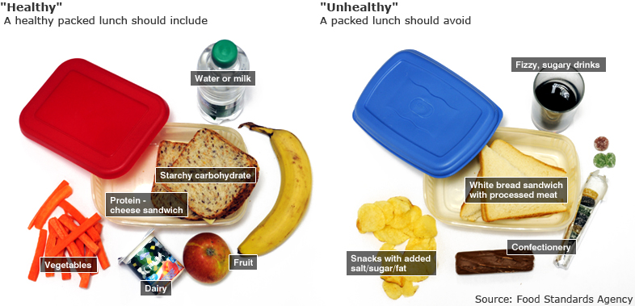

We look forward to seeing you all very soon.

Leigh and the Nursery Team

