

Summer Term 2025 Newsletter

Dear Parents,
I hope you are all having a fun Easter break so far.
The end of term show ‘Hansel and Gretel’ was a huge success. The children were amazing, and we were so very proud of them. The coffee/tea/croissants and Easter Egg Tombola raised over a £120 – thank you so much for your support. This money has been used to buy seeds, pots and potting soil for the children to grow things in the nursery garden (as well as growing a sunflower each to take home). We have also bought new play sand which is always a favourite with the children.
I thought I would update you on what has been happening at the nursery and future diary dates.

Staff News

- Holly Fox has now started her maternity leave, and we wish her all the best. We are looking forward to hearing the news and cannot wait to meet the new arrival.
- As Holly is on maternity leave I will be returning to the role of SENCO until her return.

Upcoming Fundraising Events

Sunday 18th May – Nursery Thrift Sale – Time to be confirmed (Chiddingfold Village Hall)
Kirsty Parton has very kindly taken on the role of organising the Nursery Thrift Sale this year. I will be sending out an email in the next week or so with more details. However, I do believe that the Thrift Sale will only be selling pre-loved children’s clothes and toys/furniture. In previous years we have found the adult clothes do not sell well. Please spread the word to all your friends and family to come to the Thrift Sale and pick up a bargain! Proceeds of this event will help towards a workshop/event visit to the nursery (theme yet to be decided).

Sunday 8th June – Chiddingfold Village Fete
The nursery will once again be having a stall at the fete. It has not been finalised as to what we will be doing. Any ideas gratefully received.

We will obviously need help for the Thrift Sale and the fete, if you are able to help out, please let me know.
Nursery Diary Dates
- May Bank Holiday – Monday 5th May
Nursery will be closed on this day.
- Monday 26th May to Friday 30th May
Half Term – nursery closed
- Nursery Leavers Alice Holt Trip – Tuesday 15th July
We will be taking the children who will be leaving nursery for Reception Class to Alice Holt for the day. We have booked the classroom there and will plan lots of forest adventures.
The nursery will be closed on this day.
Further details will be emailed to the parents of the ‘leavers’ in the next few weeks.
- Nursery End of Term Summer Show – Friday 18th July
The nursery children will be performing an end of term show on this day. The story is yet to be confirmed. Please note that this will not be a normal nursery day. The show will be followed by a ‘Leavers Presentation’ and a photo slide show of their last year at nursery. A very emotional day with tissues at the ready! More details will follow.

Autumn Term 2025
For those parents whose child will be returning in September 2025, if you would like to change/add days/sessions your child currently attends please could you email me as soon as possible. We have had lots of enquiries and new children starting and spaces are filling up. At the moment we have availability on all days but I would like to give our current children first choice of available sessions before they get filled. Thank you.

Funding Declaration Forms
If you have not already had a form for your child for this academic year, I will be handing them out the first week of term for those children who are eligible for ‘Funded Early Education’. Please could you complete, sign and return to me as soon as possible. Thank you.

Invoices
I will be generating invoices during the first couple of weeks of term and these will be sent via the Blossom parents app. However, please let me know if you would prefer to receive a paper copy. Please also remember that we do not accept cash payments, I am sorry for any inconvenience this may cause. We have set up a card/contactless payment device at the nursery to make it easier. You can also pay using bank transfers via online banking. Methods of payments with details will be on the bottom of the invoice.

Primary School Notifications
To the parents whose children will be starting primary school in September, I really hope you got the school of your choice and are happy. I would appreciate it if you could let me know what school your child will be going to so I can contact them to arrange for a visit from the reception teacher to our nursery and to discuss transition and reports. Thank you.

Now for the obligatory information………
Please remember to bring your child with a named coat and a named bag with a change of clothes, and a named bottle of water. Also, if possible, a pair of named wellington boots and a sunhat. As it will be the Summer Term which may mean sunnier weather (fingers crossed) please can you put suncream on your child in the morning if the forecast is for hot weather. We will reapply during the course of the day.
As you also know we are a NUT FREE nursery so any food containing nuts is prohibited, this includes Pesto as it contains pine nuts.
Popcorn is also a prohibited item as it is deemed a choking hazard for early years children.
Grapes must be cut lengthwise.

We do not allow any sugary drinks at our setting. If your child will be staying for lunch please put your child’s name clearly on the lunch bag/box as sometimes we may have more than one of the same design. As before please adhere to our healthy eating ……………

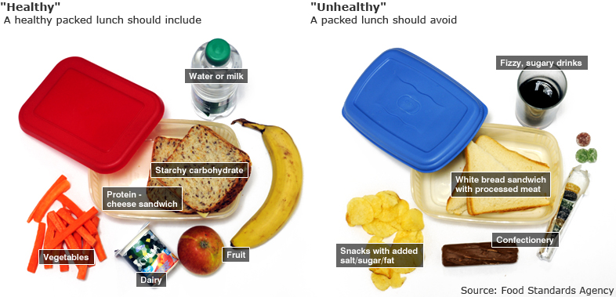

If you have any questions, please do not hesitate to contact me – administrator@chiddingfoldvillagenursery.co.uk

We are back on Tuesday 22nd April. Happy Easter.

Thank you.

Leigh and The Nursery Team

