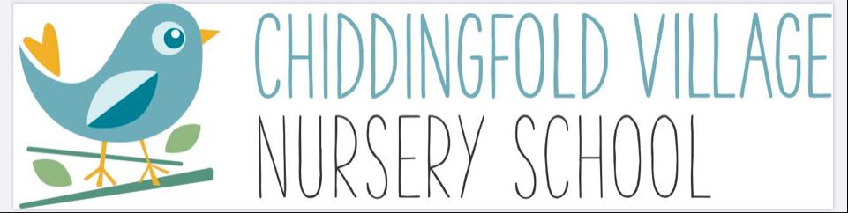

**Term Dates for 2025 – 2026**

**Autumn Term (14 weeks)**

Monday 8th September 2025 to Friday 24th October 2025

*Half Term* Monday 27th October 2025 to Friday 31st October 2025

Monday 3rd November 2025 to Friday 19th December 2025

**Spring Term (11 weeks)**

Monday 5th January 2026 to Friday 13th February 2026

*Half Term* Monday 16th February 2026 to Friday 20th February 2026

Monday 23rd February 2026 to Friday 27th March 2026

**Summer Term (13 weeks)**

Monday 13th April 2026 to Friday 22nd May 2026

*Half Term* Monday 25th May 2026 to Friday 29th May 2026

Monday 1st June 2026 to Friday 17th July 2026

**Nursery closed on the following days:**

Bank Holiday – Monday 4th May 2026

Bank Holiday – Monday 25th May 2026

Nursery Leavers Trip - Tuesday 14th July 2026