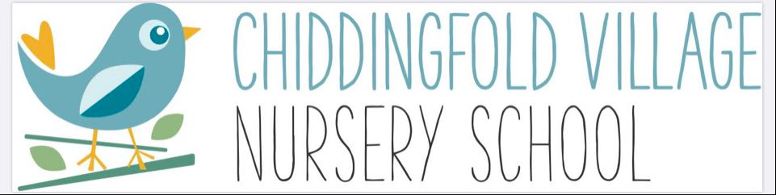

Term Dates for 2025 – 2026

Autumn Term (14 weeks)
Monday 8th September 2025 to Friday 24th October 2025
Half Term Monday 27th October 2025 to Friday 31st October 2025
Monday 3rd November 2025 to Friday 19th December 2025

Spring Term (11 weeks)
Monday 5th January 2026 to Friday 13th February 2026
Half Term Monday 16th February 2026 to Friday 20th February 2026
Monday 23rd February 2026 to Friday 27th March 2026

Summer Term (13 weeks)
Monday 13th April 2026 to Friday 22nd May 2026
Half Term Monday 25th May 2026 to Friday 29th May 2026
Monday 1st June 2026 to Friday 17th July 2026

Nursery closed on the following days:
Bank Holiday – Monday 4th May 2026
Local Elections (due to hall being used) – Thursday 7th May 2026
Bank Holiday – Monday 25th May 2026
Nursery Leavers Trip - Tuesday 14th July 2026

